

**Final System Analysis Phase Report**

**Client: Trace3**



**BUDT723**

**Business Process Analysis**

**Capstone Project**

Team Members of Group 1 (under the guidance of *Dr. Paul Shapiro*):

* Farah Bushra (primary POC)
* Harshil Patel (secondary POC)
* Siddharth Khare
* Asheer Mogal
* Pranay Reddy Anthireddy
* Niharika Gupta
* Pradyum Mohta

Document last edited on: 04-14-2024

**TABLE OF CONTENTS:**

1. Statement of Work
   1. Client Industry and Background
   2. Problems, Opportunities and Directives
   3. Project Scope
   4. Project Objective
   5. High-level Requirements
   6. Project Constraints
   7. Next-steps from our end
2. Fact-finding and information-gathering process
3. Data Flow Diagram
   1. Context Diagram
   2. Level 0
   3. Level 1
4. Entity Relationship Diagram

**STATEMENT OF WORK:**

**CLIENT AND INDUSTRY BACKGROUND**

Trace3, founded in 2002, is a technology consulting company headquartered in Irvine, California, that provides IT strategy, solutions, and services to organizations around the globe. Trace3 has continued to work on delivering cutting-edge services to companies seeking to navigate the dynamic IT landscape and maintain a competitive edge.

With collaboration with top technology names like Cisco, Dell Technologies, and Microsoft, Trace3 has ensured it provides only the best-in-class solutions that are specifically tailored to its customers' needs. With a team of experienced consultants and engineers, Trace3 provides impactful solutions that drive growth and business value.

**PROBLEMS, OPPORTUNITIES AND DIRECTIVES**

**Challenges:**Some of the challenges that are associated with this project are as follows:   
The current system has a semi-optimal quality of resource allocation and meeting scheduling  
- An iterative feedback loop regarding meetings

- Keeping track of the attendance of participants in meetings

- Datasets from Trace3 are required to tune our systems as per requirements. The data may be proprietary and there may be rules and regulations that need to be followed

- Clear communication of the agenda before the meeting begins

- Checking if the agenda of the meeting was met **Opportunities:**

- There is scope to make human resource allocation more efficient and streamlined. This will help in better time management

- Create a summary of each meeting to analyze the progress of the project.

- Make a more efficient system for Trace3 to manage their progress on different projects.

- Reminding participants about the scheduled meetings so they don't miss

- Avoiding unnecessary inclusion of employees who are involved in the high priority meets/tasks

**Directives:**

- The best design and development practices are required to be followed while creating the platform. This will also be by the compliance rules that Trace3 has set.

- The product design has to be according to the bylaws of the company

- All rules and regulations related to data-storing, record-keeping, and analysis have been followed according to what the company has set.

- Priorities will need to be given to some features of the platform which will represent the priorities in our development.

**PROJECT SCOPE**

The project will develop an effective meeting assistance tool tailored for Trace3's strategic initiative meetings. This tool integrates meeting progress tracking, categorizing time by project, and generating insightful reports and dashboards for management review. Enhanced features will include action item reporting, meeting reminders, and integration with meet scheduling tools. Please find some of the key features:

* **Dashboard Analytics:** The tool will generate reports showing the meeting progress, meeting summary, and meeting attendees; broken down by department, project, meeting, and attendee, offering comprehensive insights into resource utilization.
* **Meeting Summary Report:** As a primary requirement from Trace3, the tool will focus on accurately generating reports for each strategic meeting.
* **User Base:** The initial users of the system will include internal Strategic Initiatives (SI) team members like Project Managers (PMs) ensuring that the tool meets the specific needs of those directly involved in strategic project planning and execution.
* **Integration with Smartsheets:** The tool will be designed to integrate seamlessly with Smartsheets, allowing for the synchronization of meeting insights, action items, meeting summary notes etc. with existing project management workflows.

**PROJECT OBJECTIVE**

Develop and implement a comprehensive meeting management tool for Trace3 by November 2024 (tentative), streamlining the entire meeting lifecycle from pre-meeting planning to post-meeting follow-up. The tool will include scheduling, agenda creation (manual), document sharing, note-taking/summarizing/tracking unanswered questions (if time permits), task assignment, and analytics. Success will be measured by widespread adoption, reduced preparation time, positive user feedback on improving productivity and decision-making, and the use of analytics for data-driven insights. The tool will seamlessly integrate with Trace3's existing technology stack, including Smartsheets, Calendar, and video-conferencing tools (Zoom/Google/WebX).  
  
**HIGH-LEVEL REQUIREMENTS**

1. Development of a core meeting analysis and utilization reporting tool/dashboard. Integral analysis and resource utilization reports can be viewed here.
2. The business processes related to the meeting will be done in three sections: pre-meeting, in-meeting, and post-meeting.
3. The tool needs to be able to assist Trace3 in meeting processes such as scheduling, task creation and assignment, resource sharing, etc, as well as analyze the meeting proceedings and usage of resources.
4. Integration capabilities with the existing project management software - Smartsheet. This will create a centralized place where all data related to a meeting (inside an ongoing/completed project can be viewed).
5. Includes updations in data flows between different processes. Plus, updations in their data security and privacy protocols.

**PROJECT CONSTRAINTS**

Based on the constraints provided, here's how the project constraints may look from both the client side and the development team side:

Client-side constraints:

* **Limited Data Sharing due to Privacy**: The client may restrict the amount of data that can be shared externally due to privacy concerns. This constraint may impact the development team's access to certain data for testing or integration purposes.
* **Integration with Existing Systems**: The project requires integration with existing systems such as smartsheets, outlook etc. This constraint means that the development team needs to ensure seamless integration while respecting the functionalities and limitations of the existing systems.
* **Adherence to Regulatory Standards and Compliance**: The project must adhere to regulatory standards and compliance requirements, which can impact the development process and dictate specific security and privacy measures that need to be implemented.

Team-side constraints:

* **Well-Defined Project Scope**: The development team must work within a well-defined project scope to ensure that all deliverables can be completed within the designated timeline of 6 months.
* **Budget-Conscious Resource and Technology Usage**: Resources and technologies will be thoughtfully used to keep the project within budget constraints. This means the development team must prioritize cost-effective solutions and avoid unnecessary expenses.

**NEXT-STEPS FROM OUR END**

1. Work on the design phase deliverable has commenced. Progress is on track, and completion is expected within the next week.
2. Holding recurring meetings with representatives at Trace3 for iterative feedback sessions. Keep up the recurring meetings we are conducting with Trace3. Lindsey and Ellen from Trace3 have already indicated their availability on each Thursday/Friday for feedback and update meetings. This will enable us to keep them in the loop with developments that are being done by our team. We’ll also work on getting the evaluation letter from Trace3, which is a requirement for the next phase report.
3. Continuously gather more information and facts related to the proposed new system. This step is still ongoing as we strive to ensure comprehensive understanding and documentation.
4. Creating a DFD (data flow diagram using Visible Analyst software) that depicts the data flows, business processes, data stores etc. of the proposed new meeting management system at Trace3.
5. Additionally, any other deliverables that are required to be completed for the next phase will be brainstormed and completed, for instance, the executive summary, physical system design, CRUD matrix etc.
6. Consult with Prof. Shapiro during his office hours. We’ll receive his feedback and incorporate them into our deliverables. We are already doing this every Friday.
7. Addressing any questions or concerns that arise within the team regarding Phase 3 tasks and future activities. This step ensures clarity and alignment as we progress through the project phases.

—-SOW End—--

**FACT-FINDING AND INFORMATION GATHERING PROCESS**

**Description of the fact findings and information-gathering techniques used in studying the current systems:**

For studying the current information systems used by Trace3, we have used the following techniques - **Interviews & Observations**

1. Scheduling recurring meetings with the strategic initiative team at Trace3 (Ellen Edgington and Lindsey Little) on video conferencing. The meeting involved us asking questions about their current systems and where they would like to see improvements. This enabled us to ascertain the proper requirements of Trace3.

Profiles of the strategic initiative team:

<https://www.linkedin.com/in/ellen-edgington-psm-safe%C2%AE-5-certified-agilist-70a0495><https://www.linkedin.com/in/lindsey-jackson-little>

1. Getting the phase report drafts and related deliverables reviewed by Trace3. This step ensured alignment with Trace3's expectations, with iterative adjustments made based on their feedback.
2. Continuous communication established through email via our point of contact (Farah) with Trace3's strategic initiative team. This helped us keep track of any changing requirements. We have posted snippets of some of the information Trace3 has shared with us.
3. In addition to the continuous communication with Trace3, we also consulted with Prof. Shapiro to cross-check the drafts and other deliverables created by us.

Project Proposal shared by Trace3 before the start of the project:

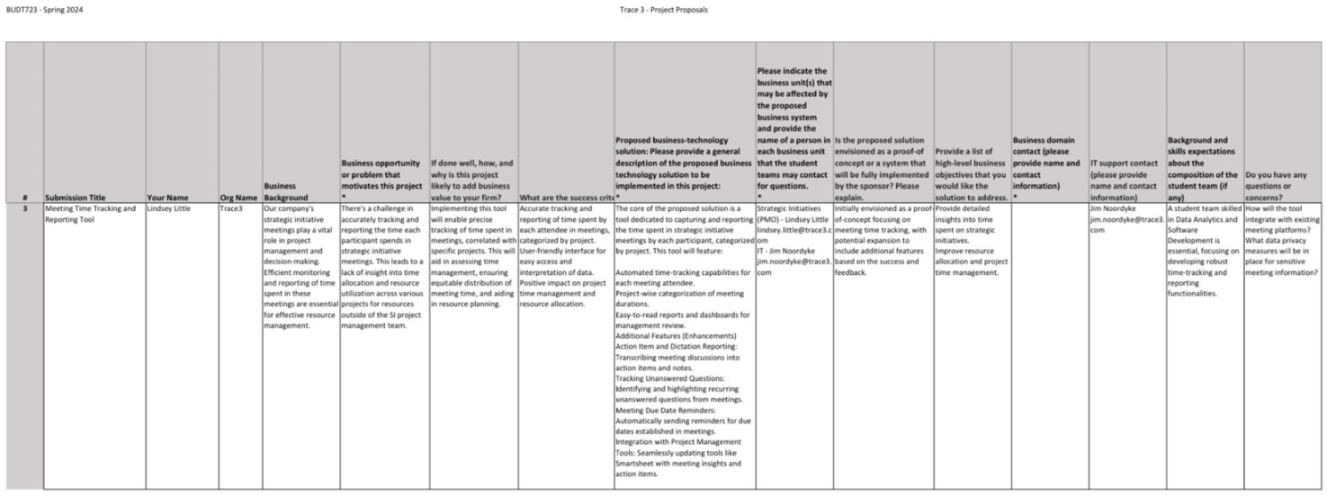

An overview of the current system for scheduling meetings & tracking project progress:

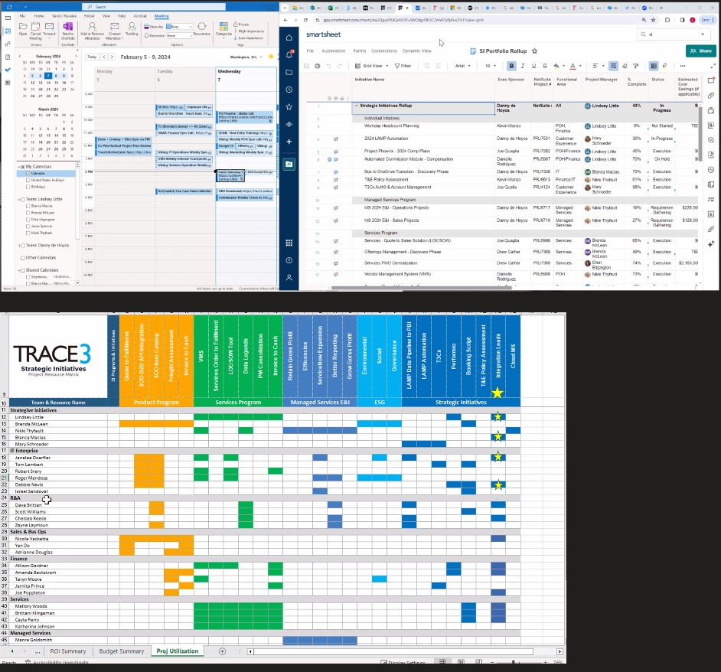



**DATA FLOW DIAGRAM**

**Visible Analyst Project Name:** GROUP1_0501_TRACE_CURRENT SYSTEM

**Trace3 - Meeting Management Tool (Current)**

**Context Diagram**

*In the above Context Diagram, there are four external entities in the current meeting scheduling system for Trace3.*

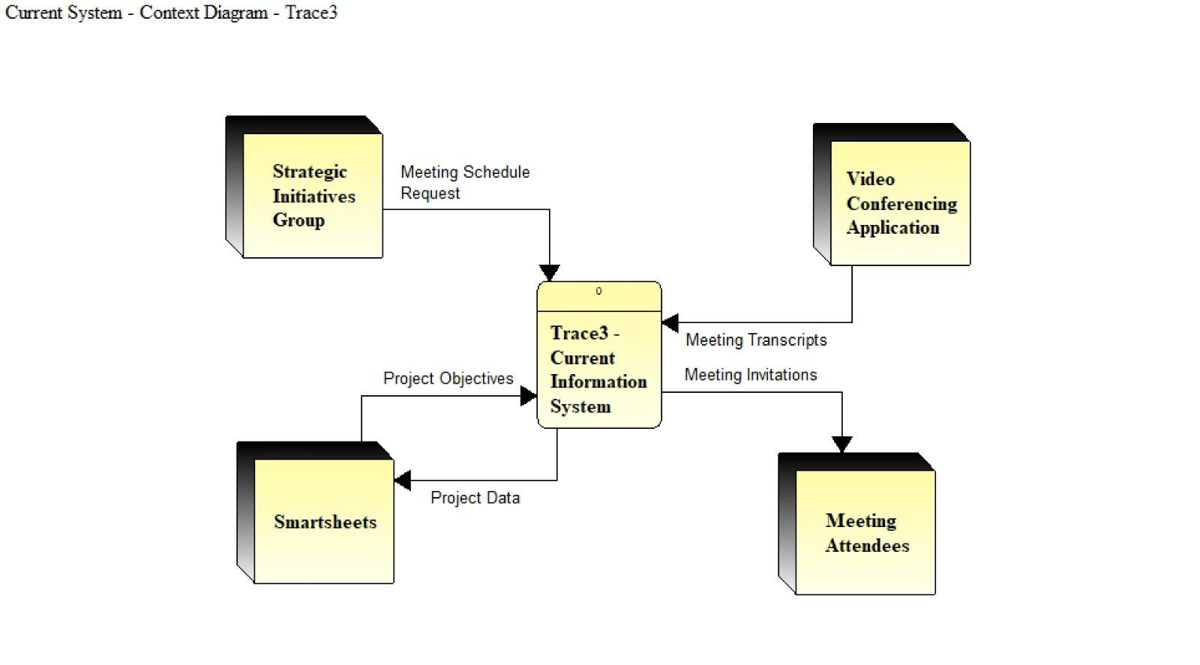

**External entities are:**

* **Strategic Initiatives Group:** This external entity represents the group of project managers responsible for scheduling and organizing meetings. They initiate the meeting scheduling process by sending meeting schedule requests to the system.
* **Video Conferencing Application:** This external entity represents the video conferencing tool (such as Zoom) used to conduct virtual meetings. The system interacts with this application to exchange meeting details, conduct meetings, and receive meeting transcripts.
* **Smartsheets:** This external entity represents the project management and collaboration tool used by Trace3. The system receives project objectives from Smartsheets and sends project data back to it for seamless integration of meeting outcomes with ongoing project tracking.
* **Meeting Attendees:** This external entity represents the participants invited to the meetings. The system sends meeting invitations to the attendees, providing them with the necessary information to join the meetings.

*Trace3 Current Information System is the logical processing system for all data used in the meeting scheduling process at Trace3. Below are system inputs and outputs:*

**System Inputs:**

* **From Strategic Initiatives Group:** 
  + Meeting Schedule Request (this request includes details such as the meeting agenda, date, time, and required attendees)
* **From Video Conferencing Application:**
  + Meeting Transcripts (the system receives text-based transcriptions of the meeting recordings)
* **From Smartsheets:**
  + Project Objectives (the system receives information related to projects, tasks, deadlines, and deliverables from Smartsheets)

**System Outputs:**

* **To Smartsheets:**
  + Project Data (the system sends meeting-related data, such as action items, decisions, and updates, to Smartsheets for synchronization)
* **To Meeting Attendees:**
  + Meeting Invitations (the system sends requests to attendees to join a scheduled meeting, providing them with the necessary details such as date, time, and joining instructions)

**Level 0 DFD**

*The Level 0 DFD expands on the context diagram, providing more details on the processes and data flows within the Trace3 Current Information System.*  
  
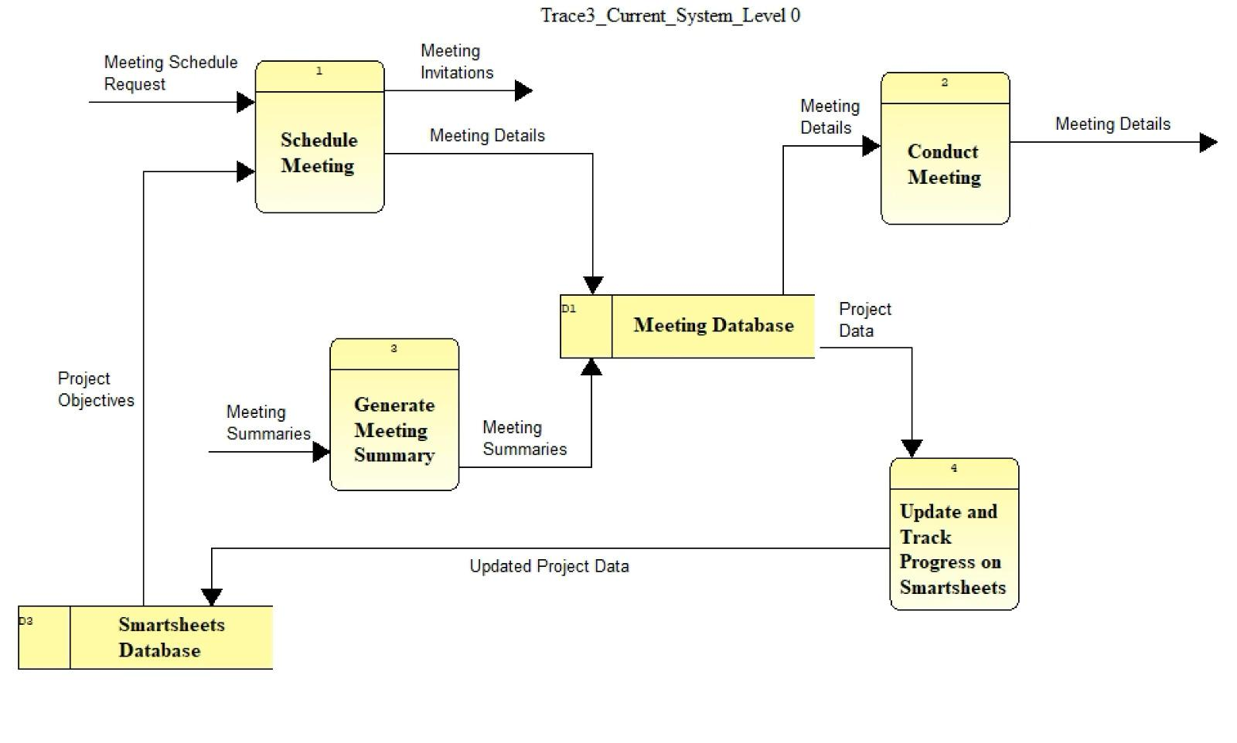

**Data Stores:**

* **Meeting Database (D1):** This data store holds all the relevant meeting information, including meeting details, attendees, and summaries. It serves as a central repository for all meeting-related data.
* **Smartsheets Database (D2):** This data store contains project-related information, such as project objectives, tasks, deadlines, and deliverables. It is used for tracking project progress and synchronizing meeting outcomes with project data.

**Processes:**

**1. Schedule Meeting:** This process manages the meeting scheduling aspect of the system. It receives meeting schedule requests from the Strategic Initiatives Group, stores meeting details in the Meeting Database, and sends out meeting invitations to attendees. The process involves the manual entry of meeting details into the system.

**Process Inputs:**

* From Strategic Initiatives Group:
  + Meeting Schedule Request
* From Smartsheet Database (data store):
  + Project Objectives (the Strategic Initiatives Group manually selects relevant project objectives when scheduling meetings)

**Process Outputs:**

* To Meeting Attendees:
  + Meeting Invitations
* To Meeting Database:
  + Meeting Details (invitations are sent via email or calendar invites)

**2. Conduct Meeting:** This process handles the actual meeting execution. It retrieves meeting details from the Meeting Database and interacts with the Video Conferencing Application to capture meeting data, such as recordings and transcripts. The system relies on the video conferencing tool's features for meeting capture.

**Process Inputs:**

* From Meeting Database (data store):
  + Meeting Details
* From Video Conferencing Application:
  + Meeting Transcripts
  + Meeting Attendance

**Process Outputs:**

* To Meeting Database (data store):
  + Meeting Data (transcripts, attendance, etc.)

**3. Generate Meeting Summary:** This process is responsible for creating meeting summaries and identifying action items and decisions. It uses the captured meeting data from the Meeting Database and the video conferencing tool's closed captioning feature to generate summaries.

**Process Inputs:**

* From Meeting Database (data store):
  + Meeting Data (transcripts, attendance, etc.)

**Process Outputs:**

* To Meeting Database (data store):
  + Meeting Summaries

**4. Update and Track Progress on Smartsheets:** This process ensures that project information remains up to date by synchronizing meeting outcomes and action items with the Smartsheets Database. It involves manual updates of project data based on the meeting summaries and decisions.

**Process Inputs:**

* From Meeting Database (data store):
  + Project Data

**Process Outputs:**

* To Smartsheets Database (data store):
  + Updated Project Data

**Level 1 DFD (Schedule Meeting Process)**

*We focus on the Schedule Meeting process from the Level Zero Diagram and expand it into three sub-processes. We also introduce a new data store, the Employee Availability Database, which is used to check attendee availability when scheduling meetings.*  
  
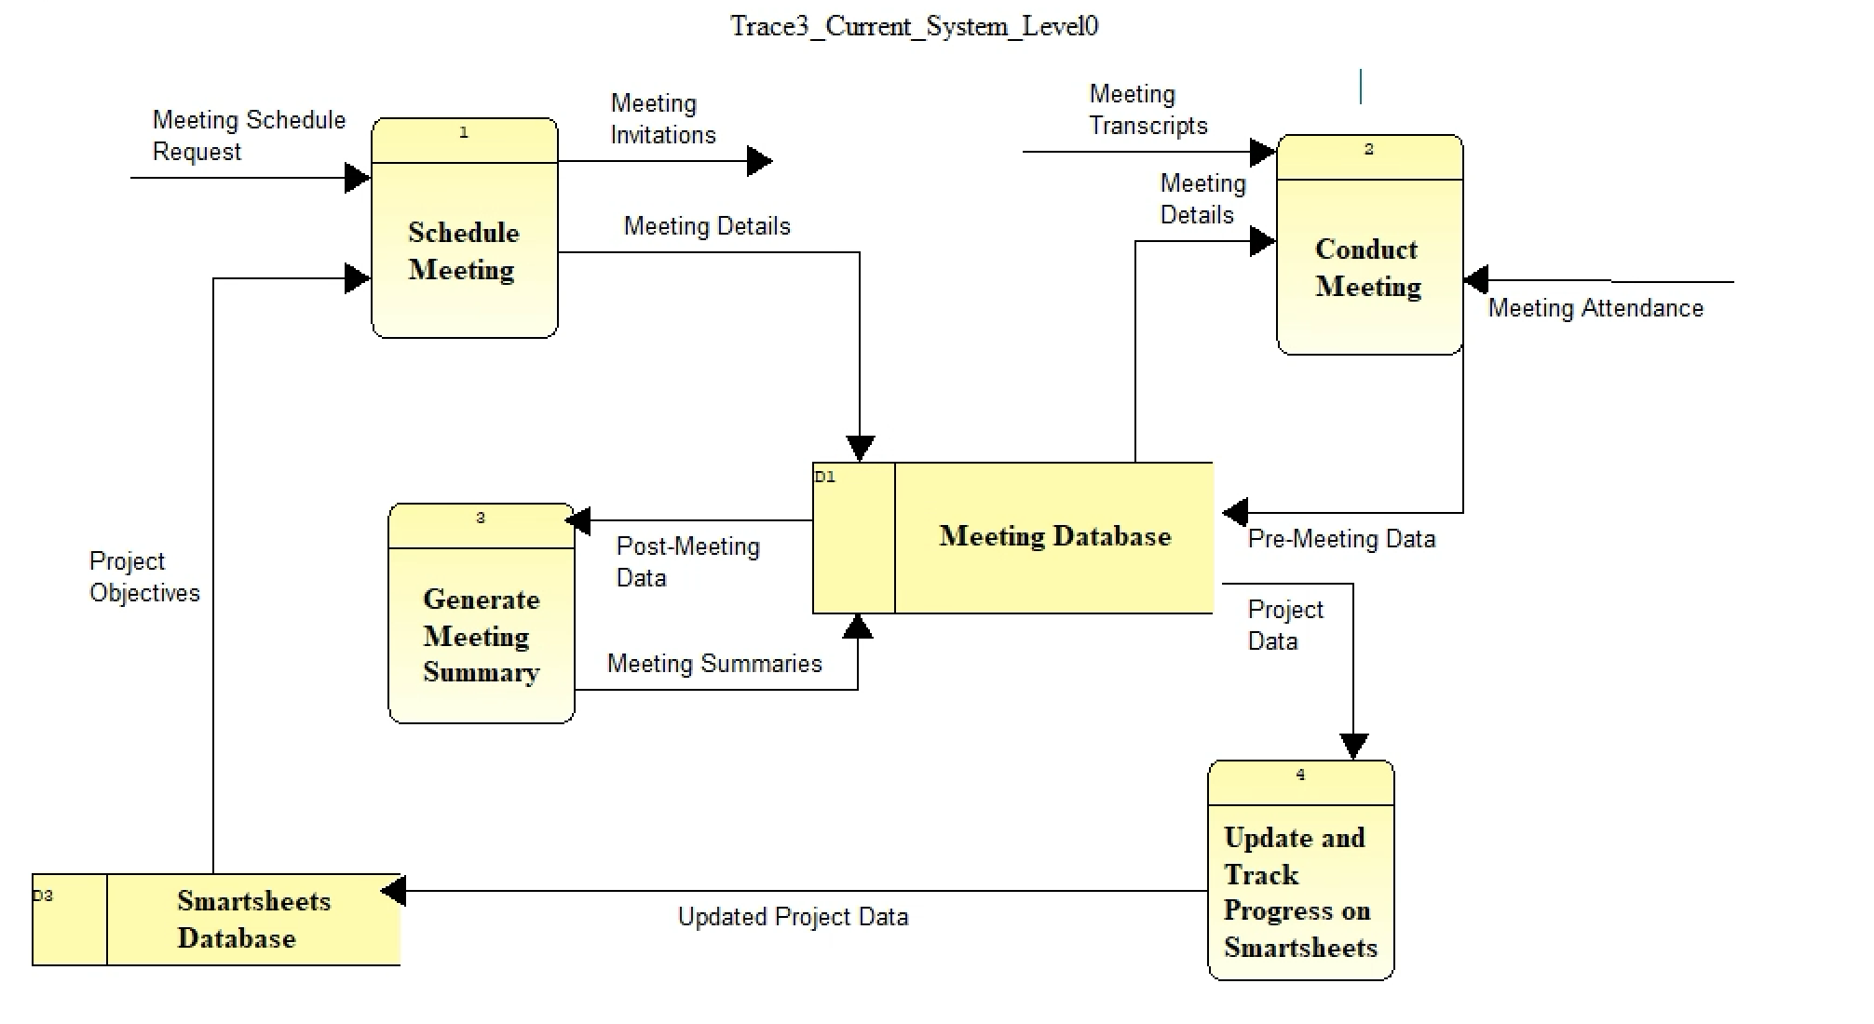

**Data Stores:**

* **Meeting Database (D1):** This data store holds the meeting details, attendees, and other relevant information. It serves as a central repository for all meeting-related data.
* **Employee Availability Database (D4):** This data store contains information about employee availability for meeting scheduling. It is used to check attendee availability when creating meeting requests.

**Sub-processes:**

**1.1 Create Meeting Request:** This sub-process initiates the meeting scheduling workflow by receiving meeting request details from the Strategic Initiatives Group, creating a meeting record, and sending the relevant information to the Check Attendee Availability and Send Meeting Invitations sub-processes.

**Sub-process Inputs:**

* From Strategic Initiatives Group:
  + Meeting Request Details

**Sub-process Outputs:**

* To Check Attendee Availability (sub-process):
  + Check Availability (the sub-process sends a request to check the availability of the specified attendees)
* To Send Meeting Invitations (sub-process):
  + Meeting Invitation Details (the sub-process provides the necessary information for sending out meeting invitations)
* To Meeting Database (Datastore):
  + Meeting Details (the sub-process creates a new record in the Meeting Database with the provided meeting details)

**1.2 Check Attendee Availability:** This sub-process receives the Check Availability request from the Create Meeting Request sub-process and retrieves employee availability information from the Employee Availability Database. It then sends the availability information back to the Create Meeting Request sub-process to ensure that the meeting is scheduled at a time when all required attendees are available.

**Sub-process Inputs:**

* From Create Meeting Request (sub-process)
  + Check Availability
* From Employee Availability Database (data store):
  + Employee Availability (the sub-process retrieves the availability information for the specified employees)

**1.3 Send Meeting Invitations:** This sub-process receives the Meeting Invitation Details from the Create Meeting Request sub-process and sends out meeting invitations to the selected attendees. The invitations include all the necessary information for attendees to join the meeting, such as date, time, location, and agenda.

**Sub-process Inputs:**

* From Create Meeting Request (sub-process):
  + Meeting Invitation Details

**Sub-process Outputs:**

* To Meeting Attendees:
  + Meeting Invitations (the sub-process sends out the invitations to the specified attendees)

**ENTITY RELATIONSHIP DIAGRAM:**

(ERD - via Visible Analyst)  
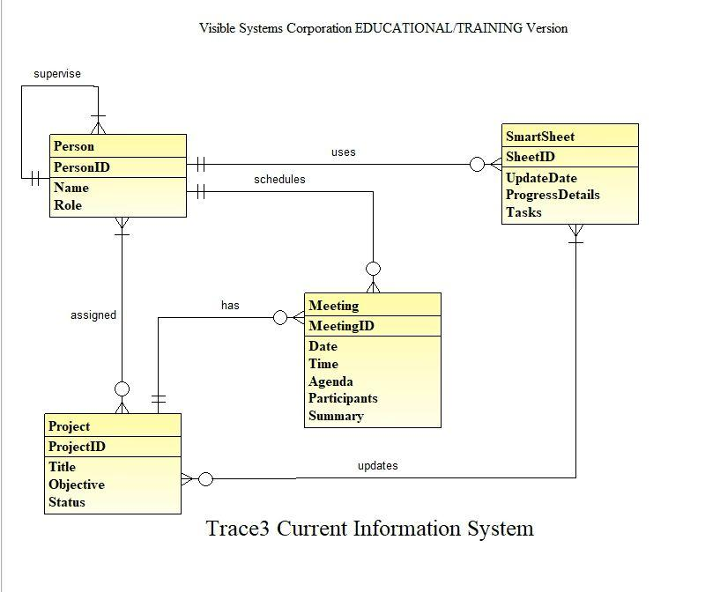

**About the ERD:**   
  
The above ERD displays the relationships and entities in the current meeting management and scheduling system at Trace3. It is a manual solution that tries to integrate with external productivity tools like WebEx, Teams, and Smartsheets.

An organizer can request a meeting by checking Employee Availability on their scheduler (Outlook) to ensure attendee availability. Once scheduled, finalized meeting details are stored in the Meeting Database, and invitations are sent out accordingly.   
During meetings, the system utilizes Zoom’s closed captioning feature to generate captions of the whole meeting. The organizer of the meeting then manually updates the status of a project in Smartsheet.  
  
Description of the entities are:

1.⁠ **⁠Person**

- This entity represents an individual involved in the project and meeting system.

- Attributes:

- PersonID: A unique identifier for each person.

- Name: The full name of the person.

- Role: The role or position that the person holds within the organization.

- Relationships:

- Supervises: A one-to-many relationship indicating that a person may supervise none, one, or multiple other people.

- Uses: Indicates that a person uses the SmartSheet.

- Schedules: Shows that a person is responsible for scheduling meetings.

- Assigned: A one-to-many relationship, indicating a person can be assigned to none, one, or many projects.

2.⁠ **⁠Project**

- This entity captures information about specific projects within the organization.

- Attributes:

- ProjectID: A unique identifier for each project.

- Title: The official name or title of the project.

- Objective: A brief description of what the project aims to achieve.

- Status: The current state or phase of the project.

- Relationships:

- Assigned: Ties the project to one or more people.

- Has: Indicates that a project has associated meetings.

- Updates: A one-to-many relationship with SmartSheet, where project details are updated on the SmartSheet.

3.⁠ **⁠Meeting**

- Represents the meetings that are scheduled and held within the organization.

- Attributes:

- MeetingID: A unique identifier for each meeting.

- Date: The scheduled date for the meeting.

- Time: The scheduled time for the meeting.

- Agenda: A list of topics to be discussed in the meeting.

- Participants: A list of people who will attend the meeting.

- Summary: A brief overview or notes from the meeting.

- Relationships:

- Has: Linked to the Project, indicating that each project may have multiple meetings.

- Updates: Shows that meeting details are used to update the SmartSheet.

4.⁠ **⁠SmartSheet**

- An entity that likely represents a customized tool for tracking project progress, details, and tasks.

- Attributes:

- SheetID: A unique identifier for each SmartSheet.

- UpdateDate: The date when the sheet was last updated.

- ProgressDetails: Information regarding the progress of tasks and objectives.

- Tasks: A list of tasks that are part of the project or meeting.

- Relationships:

- Uses: Links back to the Person, indicating who updates the SmartSheet.

- Updates: Connected to both the Project and Meeting, showing that details from these entities are used to update the SmartSheet.

—---end report—---